Unit 6 Seminar Preparation Notes
Task A:
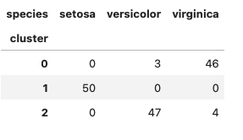
Cluster 0 – Majority Virginica – 46 correct
Cluster 1 – Setosa – 100% correct
Cluster 2 – Majority Versicolor 47 correct

143/150 = 95% accuracy

Key Takeaway: 3 clusters here worked well and species column needed to be dropped since it’s a categorical variable. Overall great performance.

Task B:

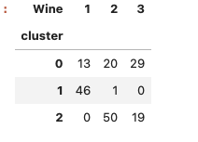
Cluster 0 – 13 class 1, 20 class 2 and 29 class 3 so not a well separated cluster
Cluster 1 – 46 class 1 ~ Strong cluster
Cluster 2 – 50 from class 2 and 19 from class 3, moderately clustered with some mixing with class 3

125/189 = 70% Accuracy
Key Takeaway: The wine column needed to be dropped, whilst it was a numeric value it wasn’t continuous and needed to be treated like a categoric variable. Wine 1 is clearly distinguishable, but wine generally is more complex and the clusters are less separated.

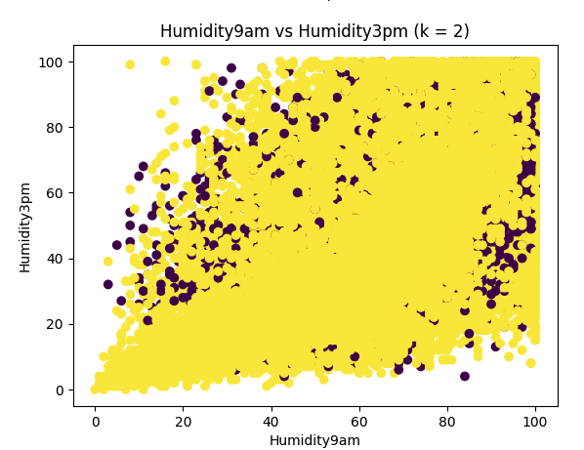
Task C:
